**Lab#1 Getting started with Springboot – Helloworld Example**

1. Create a new project from Spring.io. Add the dependencies shown. Java 17 is required for Springboot 3.

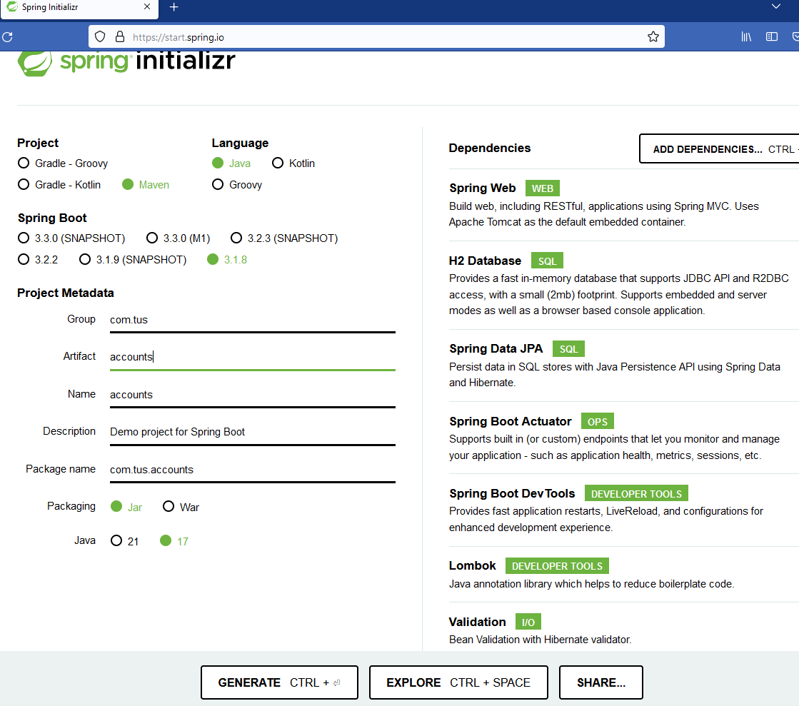

1. Generate and Import the Maven Project into your IDE.
2. Now Add a Restcontroller class to your project as shown below.

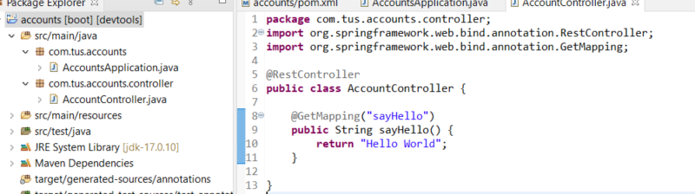

1. Test the application.

